**MULTI-LANGUAGE VOICE CONTROL IOT HOME AUTOMATION USING GOOGLE ASSISSTANT AND RASPBERRY PI**

**AIM:-**

With the advancement of technology as well as its flourished self-employed industry, everything in the house can connected and be controlled from remote locations. With something new and emerging design, the world faces its digital creation where everything is done for free and easy to people. This project reduces human activity, especially to the elderly people. Preventing them from traveling to the location where the device button is located to control it i.e. turn it off or on.

In this project, devices are controlled by providing voice commands or provides instructions using the user interface. Node MCU and Raspberry Pi are the 2 boards which are under use. Devices connected to the Node MCU can be controlled by providing voice instructions with the help of Android app and online connection. Performance is maintained by An Android application named IFTTT. Devices connected to Raspberry Pi can be controlled in user-friendly interface. The raspberry pi has similar sensations temperature sensor, light sensor and IR sensor connected to it to activate the opening and closing process devices such as light and fan based on the presence of reached with an IR sensor and available values hearing other senses.

**Hardware & Software Requirements:**

1) **Raspberry Pi**

2) **PIR Sensor**

3) **Relay Module:**

4) **IFTTT**

5) **Adafruit IO**

6) **Google Assistant**

**System Architecture:**

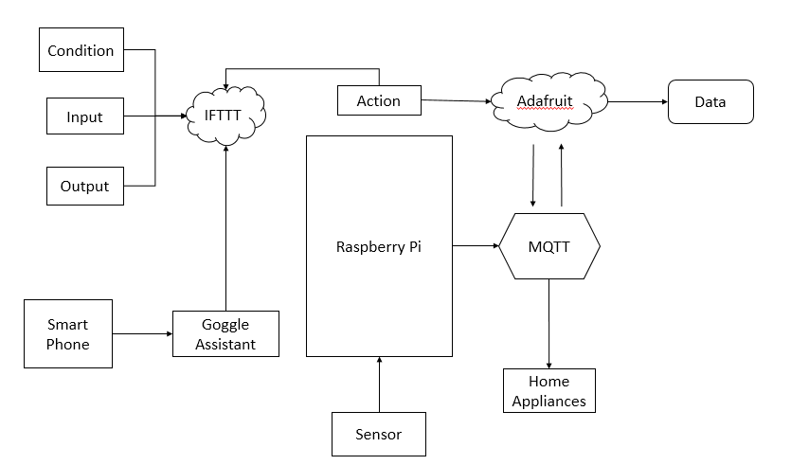

**Fig. Project Flow**

Adafruit IO is used to set up the dashboard for our application. Adafruit IO is used to set up the dashboard for our application and to provide MQTT Broker Service. MQTT is a lightweight protocol that allows multiple devices to connect to a shared server, called the MQTT Broker, and subscribe or write to user defined topics. The broker will send a notification to the device whenever that topic changes if a device is subscribed to it. Dashboards will let you directly manipulate or view the current value of each topic.

The initial setup required is creation of an Adafruit account, dashboards and feeds in the account, and including libraries in the program. Once the initial setup is done, connection has to be established between IFTTT, Adafruit and Google Assistant.

You speak your command via Google Assistant enabled device. Google voice services transcript it and search the different providers for one that can handle it, including IFTTT. IFTTT grabs the command and tells GA “yeah, I can do that”. IFTTT translates it again based on an applet you have defined. The action in applet instructs IFTTT to tell Adafruit IO to complete a request. Adafruit IO performs the request to an address that points to the connected device. Your device executes the action.

**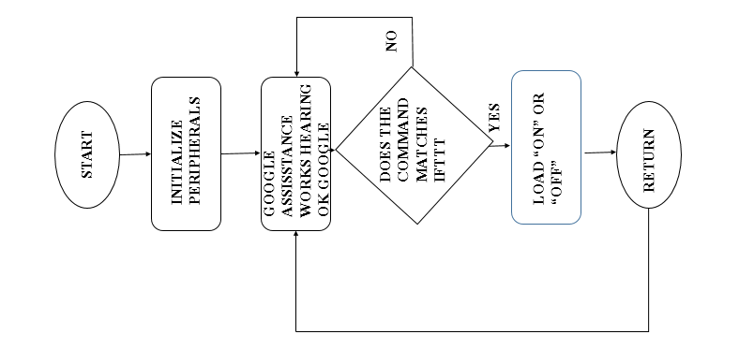**

**Fig. Workflow Diagram**

**Proposed System**

**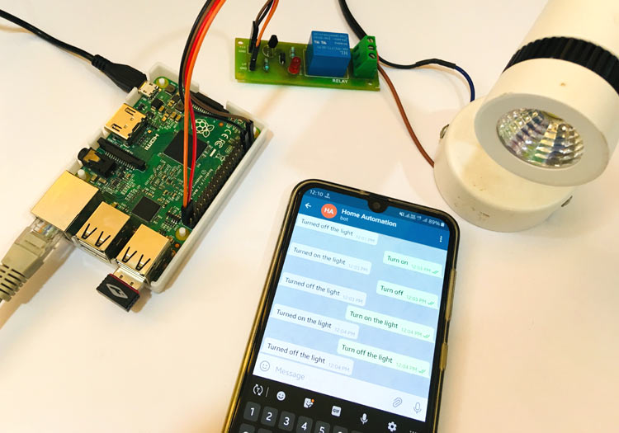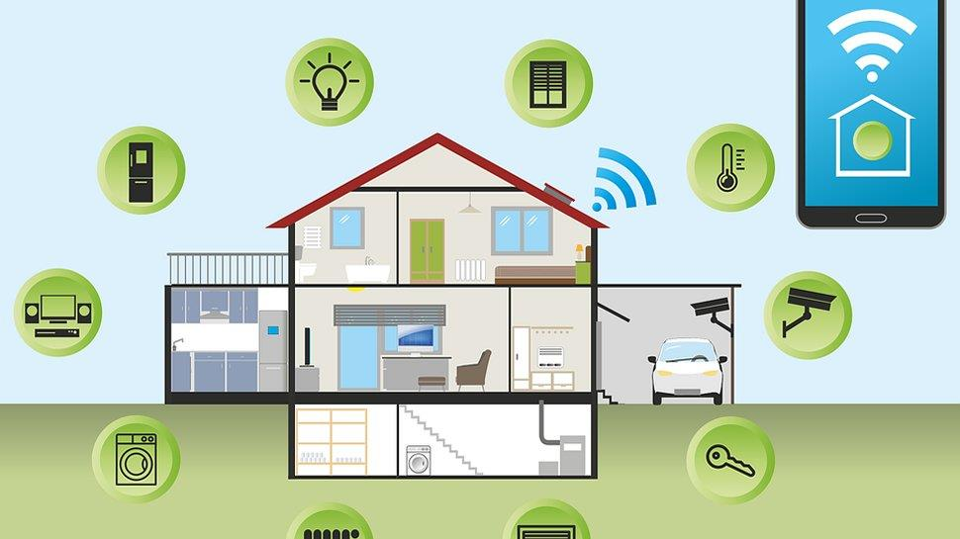**

This project aims to provide an easy and efficient way to interact with home appliances by giving voice commands in human language. The appliances are connected to the mobile device through a Raspberry Pi or Node MCU that establishes the concept of Internet of Things. The Raspberry Pi and Node MCU are interfaced with the appliances and programmed in such a way that they respond to mobile inputs. Our project automates the operation of every single appliance in the house, which greatly reduces the power consumption due to excess use/wastage of the appliance services. It also reduces the effort put by human beings to a great extent. The proposed system has a great flexibility by using Wi-Fi technology to interconnect its distributed sensors to home automation server. This decreases the deployment cost and increases the ability of system reconfiguration and upgradation. Also flexibility is increased by giving users an option to specify the commands according to their comfort and also in the language they prefer. Automatic switching on and off certain appliances such as lights and fan happen by identifying the presence of human beings as well as by identifying the environmental conditions through sensors. This system satisfies the users to a better extent by enabling them to operate their devices using specific, personalized operations pertaining to devices of the user’s choice.

**Types of Home Automation Systems**

Implementation of home automation depends on the type of controls like wired or wireless. There are mainly three types of home automation systems:

1. Power line Based Home Automation
2. Wired or BUS Cable Home Automation
3. Wireless Home Automation

**1. Power Line Home Automation System**

This automation is inexpensive and doesn’t require additional cables to transfer the information, but uses existing power lines to transfer the data. However, this system involves a large complexity and necessitates additional converter circuits and devices.

**2. Wired Home Automation System**

In this type of automation, all the home equipment is connected to the main controller (programmable logic controller) through a communication cable. The equipment is attached with actuators to communicate with the main controller. The entire operations are centralized by the computer that continuously communicates with the main controller.

**3. Wireless Home Automation**

This is the expansion and advancement of wired automation which uses wireless technologies like IR, Zigbee, [WI-Fi](https://www.elprocus.com/how-does-wifi-work/" \t "_blank), GSM, Bluetooth, etc., for achieving remote operation. As an example, the GSM based [home automation](https://www.elprocus.com/home-automation-system-applications/) provides the controlling of home equipment by an SMS to the GSM modem.

As a practical example, the following home automation system project, in which loads are controlled by a touch panel, is very informative.

**Stake holders:**

**Consumer IoT**

As a starting point, a consumer is someone who buys goods or services for personal use. Now, if we talk about “Consumer IoT," we're just adding the smart side.

Basically, Consumer IoT solutions are focused on individual users or families through the use of wearables, smart home applications, and personal monitoring devices. A suitable example are voice smart assistants such as Amazon’s Echo, Google’s Home, and Apple’s HomePod; in other words, products that make our lives easier by performing tasks or services for us. Another common example are smart thermostats and off when the indoor climate is in the perfect conditions for us, even if you're away from home. The common connectivity used in this kind of solutions are Bluetooth, WiFi, and ZigBee. These technologies offer short-range communication, suitable for applications deployed in limited spaces such as houses, or small offices.

**Commercial IoT**

Commercial IoT targets our daily environment outside of the home (consumer IoT). There is a set of applications that can be deployed in places we frequently visit such as commercial office buildings, supermarkets, stores, hotels, healthcare facilities, or entertainment venues. The applications for these places vary from variables monitoring to environmental conditions, personal control schedule, building access, as well as connected lighting, asset tracking, and many more. These types of applications provide a better experience to guests in places like hotels and restaurants through more efficient monitoring in smart buildings and smart offices.

Commercial IoT solutions are open to any connectivity type like Bluetooth, WiFi, ZigBee, Sigfox, LoRa, and LTE.

**Industrial IoT**

Unlike Consumer IoT, Industrial IoT targets existing automated industrial systems looking for dramatic improvements in productivity and efficiency. The most common sectors that come to mind could be large scale factories or manufacturing plants, but these are also known for monitoring utilities and expensive assets. Basically, we can say that we’re entering a whole new era of IoT.

The existing automated industrial systems inside factories tend to be older because the systems may have been installed more than a decade ago, therefore, integrating the information from these systems to support IoT could get more complicated than commercial IoT, due to the tasks that integrators have to do carry out, manage, and adapt to the existing infrastructure.

In order to allow for a suitable and scalable solution, industrial solutions should include gateways.  Basically, these gateways can be a device or a software program that allows for the connection between the Cloud and sensors or controllers. One of the principal uses of gateways are to translate the protocols used in the manufacturing plant to the supported one to handle data with the Cloud. Aside from this, gateways are efficient avenues for data logging and processing solutions, allowing integrators to offer more user customization, as well as running user applications in order to adapt them for specific industrial processes.